Selecting the right EMIS for your needs – Workshop 1
Participant Workbook

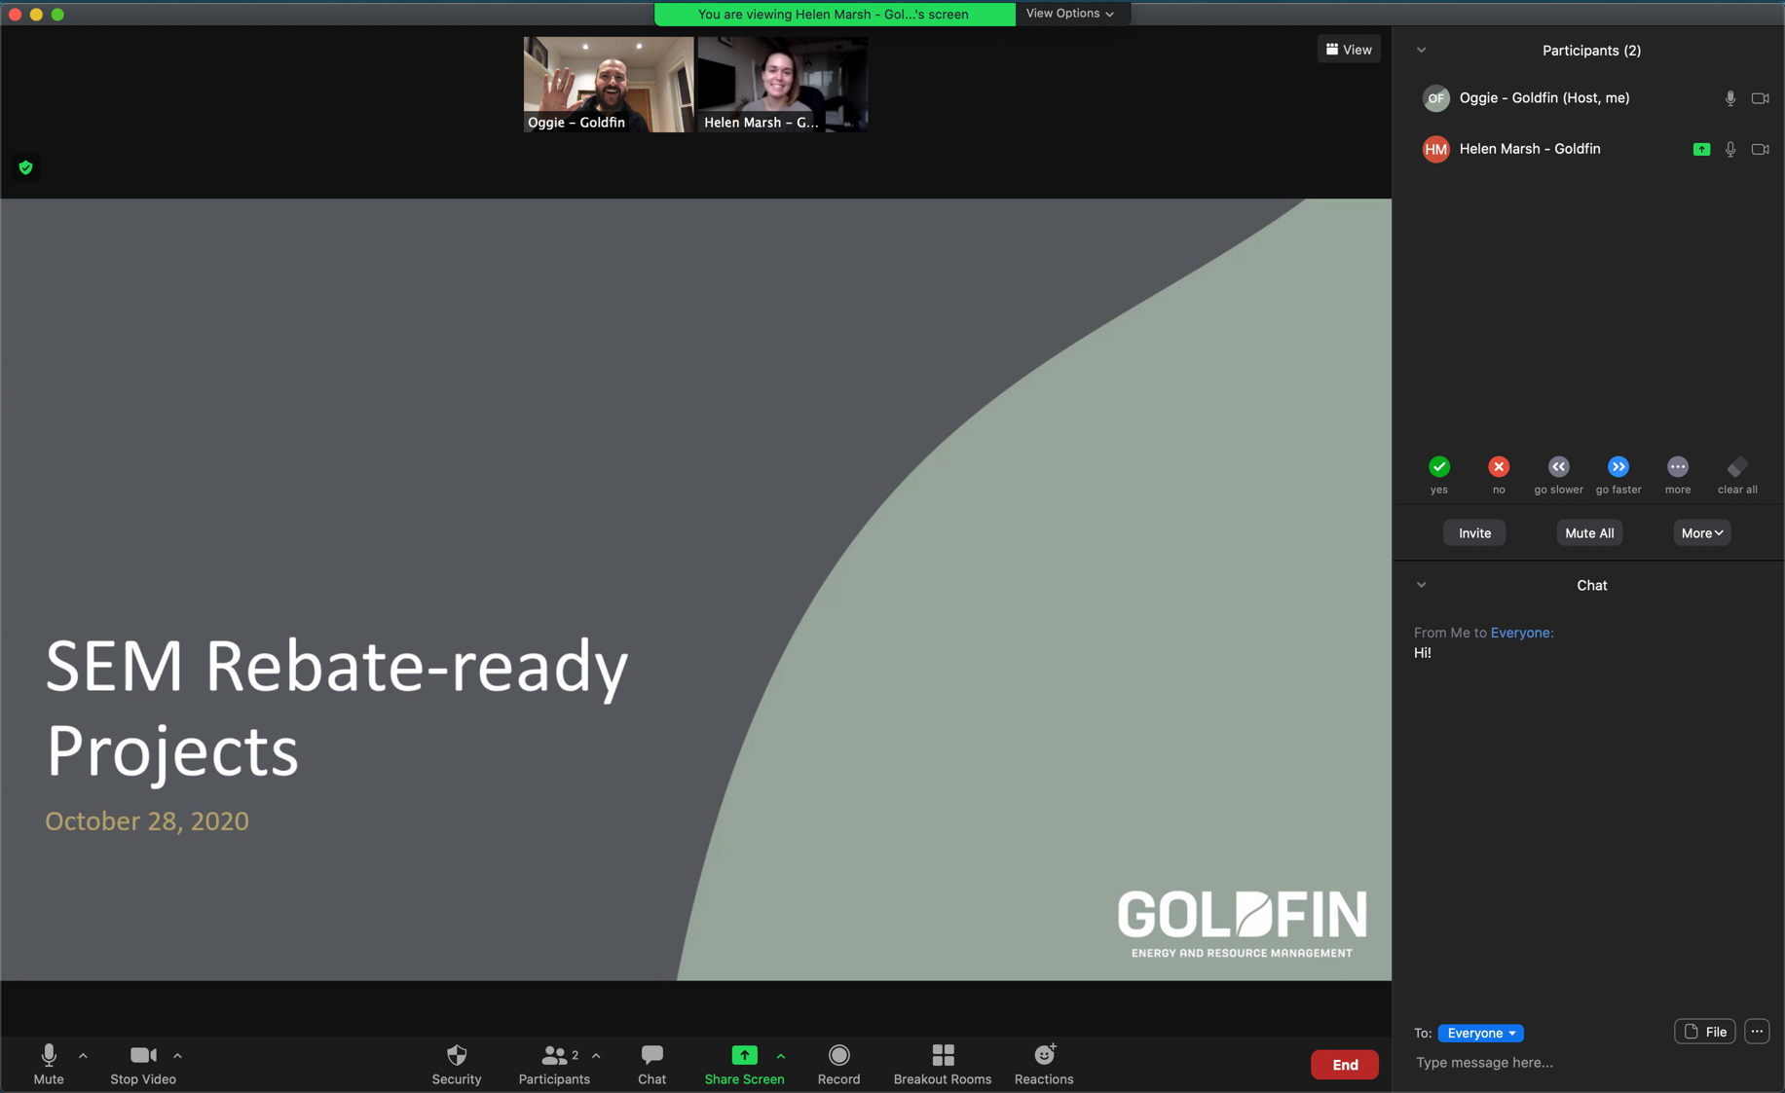

An energy management information system (EMIS) can provide organizations with valuable insights that can lead to reduced utility costs, reduced GHG emissions, improved maintenance practices, evidence of energy savings, and better decision making. However, implementing an EMIS system can require a significant investment of time and money and with so many options available, organizations can become overwhelmed when it comes to choosing the EMIS that’s right for them.

This workshop will guide participants through the process of selecting and planning an EMIS that aligns with their organization's needs. This includes understanding how to effectively evaluate their current situation and needs, build a strong business case, identify and engage suitable vendors, and ultimately evaluate and select the vendor that best meets their requirements.

In this workshop, Participants will:
- Understand what types of EMIS are appropriate based on your
current situation and needs
- Explore key considerations when selecting an EMIS
- Begin developing a plan to define, identify,
and select an appropriate EMIS
This workshop will be hosted via Microsoft Teams.
For instructions or troubleshooting please
see the last page of this workbook.

What is an EMIS?
An Energy Management Information System (EMIS) provides critical information to make energy performance visible and actionable across your organization. It collects energy data from meters, stores it and converts it into performance reports that offer insights and identify opportunities for improvement. When paired with effective management practices, this information becomes a powerful decision-making tool.

EMIS is a combination of hardware and software.
- Meters and sensors
- Data infrastructure
- Servers or cloud storage
- Software platform

Benefits of using an EMIS
- Reduce energy consumption and GHG emissions
- Reduce utility costs
- Improve operational performance
- Improve decision making

Types of EMIS
It is important to choose an EMIS that matches your needs. While there are different classification systems for EMIS, this fact sheet groups them into three categories.
Basic EMIS
Basic systems rely on manual or basic automated data entry collected from utility and submeters. They have limited analysis capabilities and can be as simple as an Excel workbook.
Advanced EMIS
Advanced systems allow for automated data collection and analysis, offer flexible reporting and can support multiple sites.
Real-time EMIS
The most sophisticated option, real-time systems are ideal for complex operations. They offer continuous data integration, advanced analytics and seamless connectivity to other operational systems.

Understanding different EMIS use cases
For each use case, highlight one to four stars to indicate how relevant or important that use case is to your organization.
Use cases | Relevance
Reduce energy consumption and costs  Monitor energy consumption trends to understand how energy use relates to operations and uncover opportunities to reduce energy waste. | ☆ ☆ ☆ ☆
Benchmark performance  Monitor and compare energy performance between similar systems, production lines, or facilities to help focus efforts or report progress over time. | ☆ ☆ ☆ ☆
Improve decision-making  Energy data can be used to focus efforts, prioritize opportunities, forecast energy consumption and costs, and inform the business case for energy improvements. While submetering plays a key role, decision-making can often be improved. | ☆ ☆ ☆ ☆
Allocate energy-related GHG emissions and costs  Measure energy consumption at specific areas and times to allocate energy-related GHG emission and costs to specific departments or production outputs. | ☆ ☆ ☆ ☆
Influence behaviour  Energy data can be used to prompt specific behaviours such as shutting down equipment outside operating hours, closing doors or windows, or reinforcing standard operating procedures. While a basic EMIS can help reinforce behaviours, many of these applications require real-time prompts to be effective. | ☆ ☆ ☆ ☆
Support preventative maintenance  Increased energy consumption can indicate when controls are stuck, actuators broken, filters need changing, or when motors or other equipment needs servicing. | ☆ ☆ ☆ ☆

Aligning organizational Priorities with EMIS types
The table below summarizes which level of EMIS (basic, advanced, or real-time) you may need depending on the use cases that are important to your organization.
EMIS use cases | Basic | Advanced | Real-time
Reduce energy consumption and costs | þ | þ | þ
Benchmark performance | þ | þ | þ
Improve decision-making. | þ | þ | þ
Allocate energy-related greenhouse gas (GHG) emissions and costs | o | þ | þ
Influence behaviour | o | o | þ
Support preventative maintenance | o | o | þ

For example, organizations that are just getting started and looking to start reducing energy consumption and improve decision-making may only need a basic EMIS at this point. However, an organization that wants to further reduce energy consumption and use the EMIS to support participation in demand reduction programs and support preventative maintenance efforts may need a more sophisticated real-time EMIS.
These needs may change over time.

What level of EMIS does your organization need right now?
Highlight the type of EMIS below that will support your current relevant use cases.
Basic EMIS | Advanced EMIS | Real-time EMIS

EMIS Key considerations
Key Consideration | Questions to Ask | Who to involve
Data sources  Simple systems may collect energy data from a handful of current transformers while an advanced system may have hundreds of data sources. | What meters are already in place?  What meters (and specifications) will be needed?  What other data should be captured? | Engineering and instrumentation personnel  Operations personnel  IT department  Department managers
Data integration and flexibility  Organizations may have legacy systems that need to be integrated. Proprietary data systems can provide benefits but may lock you in. Data needs may change. | Can it integrate with existing metering and systems?  Can it grow to accommodate new data sources?  Will it be able to meet changing needs? | IT department  Engineering personnel  Operations Management  Management
Data capture  Wireless connections can reduce costs, but some facilities may require the reliability of wired meters. Understand existing network infrastructure design. | How will data be collected from meters?  Will data connections be wired or wireless?  Is new infrastructure required? | IT department  Instrument and Electrical Technicians  Engineering personnel
Reporting and analytics  Some organizations may many audiences with complex data needs. Other organizations may not require complex analytics. | Can it analyse real-time data and historical trends?  Can it meet all reporting needs, including regulatory?  Can it create custom dashboards or reports?  Can it provide notifications of certain events? | Managers, Operators, and Engineers  IT department  Energy and Environmental Managers  Executives
Ease of use  Large organizations may have specialized staff to operate the system but even then, staff will need some training. Consider how people who aren’t typically using the system will get actionable data. | How easy is it to create custom reporting?  Is it easy for different departments to understand the desired insights?  How difficult is it to train and get people using it? | Operations personnel  Operations management  Engineering  Executives  Accounts  Planning and scheduling
Security, data privacy, and reliability  Some organizations may have strict data-security policies and reliability requirements while others may just want a system that meets industry standards. | Will data be stored on-site or in the cloud?  Does it comply with security requirements?  Can it meet uptime requirements? | IT department  Legal and Compliance departments  Senior Management
Vendor support and reputation  In addition to confidence in vendor capabilities, some organizations may place additional emphasis on strong vendor support, particularly if the system may impact sensitive or mission-critical operations. | Do they have a track record on similar projects?  Do they provide adequate support, updates, and system monitoring?  How will they adapt to emerging technology? | The project team  Procurement department  IT department  Senior management
Costs  It’s important to consider the upfront costs and the ongoing costs of using, maintaining, and upgrading the system. There may be trade-offs between using knowledgeable internal staff versus vendor support. | What are the initial costs?  What are costs for training and support with implementation?  What are ongoing maintenance and support costs? | Finance and Accounting departments  Procurement department  Project management  Senior management

Practice Case Study
A large manufacturing facility produces parts for eight different customers. They currently download monthly electricity and natural gas consumption data and have a building automation system that controls their exhaust fans, make-up air units, and space heaters.
The facility has high energy costs that are difficult to track or attribute precisely below the main meter level. They have some basic sub-metering, but the data isn't easily accessible or used by operational teams. This makes it challenging to identify specific energy waste and integrate energy insights into daily operations or maintenance planning.
They want to install an EMIS to:
- Reduce energy consumption and costs.
- Allocate energy costs and GHG emissions to specific customers.
- Improve preventative maintenance practices to reduce downtime.
Their priorities are to:
- Collect reliable, frequent data across a large and crowded facility.
- Integrate energy data with existing process and production data.
- Communicate actionable insights to many different audiences.

Your key considerations
A key consideration might be rated important if:
- Your organization has a clear preference or priority (e.g. tight security controls), or
- It’s not clear what your organization’s preference or priority is, but it will be important to figure out.
For each of the key considerations in the table below, rate how important they are to your organization when planning their EMIS where 1 is not important and 5 is very important. Refer to page 4 for details on key considerations.
Key Consideration | Ranked Considerations (1-5)
Data sources
Data integration and flexibility

Data capture

Reporting and analytics

Ease of use

Security, data privacy, and reliability

Vendor support and reputation
Costs

Planning your EMIS

Evaluate needs
This first step provides a foundation on which to build your EMIS design. It can be carried out internally or with the assistance of an EMIS auditor. It involves:
Defining the purpose of the EMIS:
Gather input from across the organization on what the EMIS should achieve, how it will operate, and what results it should deliver.
Understanding its integration with organizational management
Review existing management systems and identify what’s needed to translate insights from energy data into action items.
Defining energy account centres
Establish energy account centres — the organizational building blocks at which energy performance is measured — and assign ownership to specific teams or departments.
Assessing metering, data capture, data analysis and reporting
Create an inventory of equipment, including specifications, current operating conditions, key energy drivers, existing data availability, and how the equipment should be managed. This will inform the scope of the EMIS project and support the development of the business case.

Build the business case
Reaching a consensus on the purpose and key use cases of an EMIS for your organization will inform the selection process and help determine the most suitable system, while addressing the concerns of all departments. The inventory of equipment and current operating conditions from the previous step can estimate potential energy savings. Energy cost savings can include the reduction of energy performance variance (regression analysis can help assess the amount of variance that cannot be explained by changes in energy drivers) and operational improvements identified through the EMIS. Non-energy benefits may include improved preventive maintenance, increased resilience or improved operational data.

Identify and engage vendors
EMIS vendors can be found through online directories, industry trade groups and professional networks. Large organizations may already have lists of approved vendors; if not, consider reaching out to peers in similar organizations.
Once potential vendors have been identified, ask them to self-assess their suitability based on your situation and needs assessment. You should also request a demonstration of their software, as well as case studies or results from previous customers. Finally, invite vendors for a site tour and, if they have any questions, share the questions and your responses with all potential vendors.
A formal Request for Proposals (RFP) is a reliable method to solicit bids. The RFP should be clearly written, setting out the scope of the EMIS, the desired inputs from the vendor, and containing sufficient information for vendors to prepare bids on a common basis. This information includes details on existing utility systems and capacities. Due to the inclusion of potentially commercially confidential information in the RFP, obtaining signed Confidentiality Agreements from potential vendors prior to issuing the RFP may be necessary.

Evaluate and select a vendor
To accurately evaluate different vendor proposals, create a matrix with weighted criteria based on the results of your situation and needs assessment. Determine the features that are critical, important and less important, then assign appropriate weights. It’s also helpful to have multiple people evaluate the bids against these criteria. To compare the costs, divide each bid’s total by its evaluation score. This will give you a relative measure of cost per point.

Planning your EMIS – Activity

What stage of choosing an EMIS are you currently at?
Refer to the previous pages and highlight one of the steps below.
- Evaluate needs
- Build business case
- Engage vendors
- Select vendor

What information gaps need to be filled to move to the next stage?
Refer to page 4 for ideas of which key considerations you might need to gather information on.

Who do you need to involve in the process to help address those gaps?
Refer to page 4 for ideas of who to involve in the discussion of each key consideration.

Additional Resources

Incentives for EMIS
- Save on Energy: Expanded Energy Management Program

EMIS Planning Resources
- Natural Resources Canada: Energy Management Information Systems Planning Manual and Tool.
  - Note: if you end up in an endless loop of clicking “Continue to publication”, right-click the “Continue to publication” button and select “Save link as…” to save the PDF to your computer.
- Natural Resources Canada: EMIS Business Case Tool

