The Value of energy management information systems (emis) when returns on investment (rois) are difficult to prove
Participant Workbook

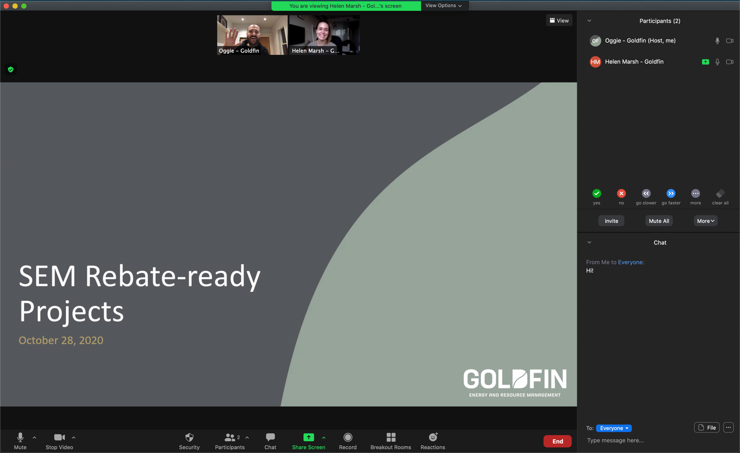
This workshop is hosted via Microsoft Teams.
For instructions or troubleshooting, please
see the last page of this workbook.
This workshop is focused on how energy managers successfully make the case for EMIS in real-world conditions. Rather than relying on precise return-on-investment calculations, participants learn how to construct a practical, defensible business case using available data, operational context, and conservative assumptions.

In this workshop, Participants learn to:
- Describe how ROIs are estimated in practice using blended and conservative assumptions
- Identify the types of value EMIS create beyond direct savings
- Describe how to justify and realize EMIS value in practice to develop a strong business case for your stakeholders

Where the case for EMIS breaks down
- You are expected to justify value before the system is in place.
- Much of the value depends on future actions and decisions.
- Savings are often indirect and difficult to isolate.
- EMIS is often compared to projects with clearer financial returns.

what goes into the estimate

(the Three-bucket LisT)

Operational savings

Can you identify energy reduction opportunities in a manner that can be quantified or measured?
Savings can be identified via:
People-based approaches:
- Site walkthroughs
- Energy audits
- Employee suggestions
- Comparing operations to best practices

Available data sources:
- Existing programmable logic controller trends
- Interval utility data
- Building automation system/supervisory control and data acquisition trends
- Maintenance logs

List your operational savings.

Non-energy benefits
Examples include:
- Faster issue detection
- Decision confidence
- Maintenance insight
- Budgeting support
- Measurement and verification support
- Operational accountability

Can you identify organizational benefits and priorities in a manner that appeals to stakeholders?
- Use operational history and recurring issues as directional evidence, not exact proof
List your non-energy benefits.

Future project enablement
Examples:
- Directly quantify other energy projects
- Justify gut feelings
- Justify design choices

Does this lead to a better or more confident stakeholder decision about the enablement of broader projects and opportunities?
List your non-energy benefits.

DeRisk your case
- Remove value claims that you cannot explain:
- If you cannot clearly explain how the EMIS led to the outcome, do not include that value estimate.
- Example: "We think maintenance improved because of EMIS" is too weak if the link cannot be demonstrated.
- Use conservative savings assumptions:
- Take your initial assumptions and make them more conservative.
- Example: If you believe the opportunity is worth 10%, build your business case using 3 to 5%.
- Anchor estimates to evidence:
- Use actual utility spend.
- Use documented operational issues.
- Use known equipment performance problems.
- Use previous project results where available.
4. Show the range, not a single number:
- Clearly distinguish between benefits already demonstrated and benefits expected in the future.
- Stakeholders typically trust observed value more than projected value.

Go back to your Three bucket lists on page 3.

Refine your Case using the derisk framework.

present your case
Your presentation should respond to the following common questions:
- What is the savings range?
- Can’t we already see this in our data?
- Why do we need another system?
- Who’s going to pay for this?
- Do we have the capacity/resources to make use of this system?
- Who’s going to run and maintain this?
- What is the risk if we don’t do this?

Stay connected with tools and resources
- Virtual one-on-one coaching: Post-webinar support intake form for tailored support for organizations to manage energy resources effectively
- Monthly bulletin: Sign up to receive monthly training updates on all Save on Energy training and support for new tools and resources
- Live training calendar: Visit this page to easily register for upcoming events and workshops
- Training and support webpage: Visit this page to access all training and support materials
EMIS incentives are available through Save On Energy’s Expanded Energy Management Program.
Projects must be completed before February 2027 while funding is available. To start your application process, please email SEM@ieso.ca.

