Driving continuous improvement with Energy Management Information Systems (EMIS)
Participant Workbook
This workshop is part three of the Sustaining EMIS Workshop series. It is focused on how to establish continuous improvement processes to manage and operate your EMIS. It includes examples of the Plan-Do-Check-Act (PDCA) cycle relevant to EMIS operation and advice on how to ensure your EMIS is incorporated into your broader energy management system (EnMS) while following the best practices detailed in ISO 50001.
This workshop conducts a deep dive on EMIS benefits and how your EMIS can be leveraged for continuous improvement, including identifying new project opportunities.

In this workshop, Participants will:
- Recognize how continuous improvement and the PDCA cycle support long-term EMIS success and how to integrate an EMIS within an ISO 50001 energy management system.
- Apply a practical framework to sustain and improve EMIS performance by prioritizing data, tailoring communication to different stakeholders, building credibility through small wins and integrating EMIS into organizational decision-making.

- Identify one practical opportunity to improve the value of their organization’s EMIS by recognizing common pitfalls, evaluating their current approach and determining a next step to strengthen continuous improvement efforts.
This workshop is hosted via Microsoft Teams.
For instructions or troubleshooting, please
see the last page of this workbook.
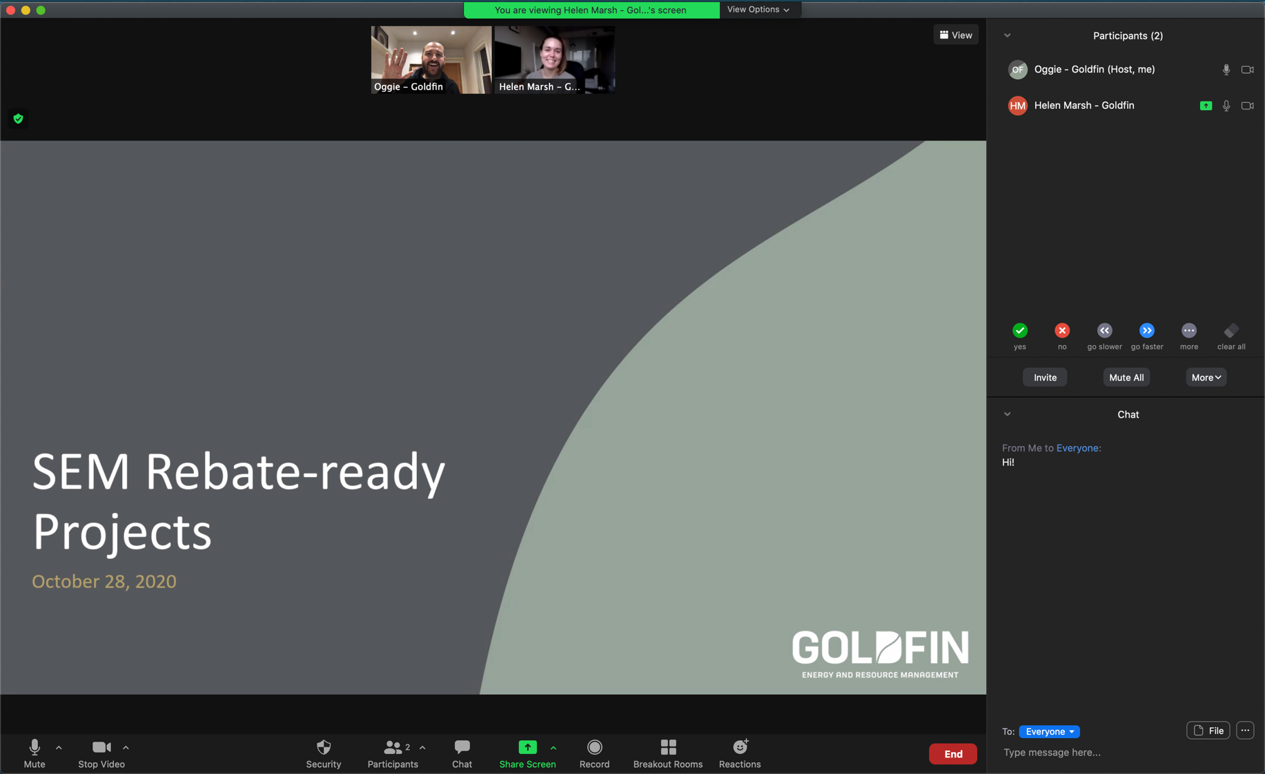
Getting Started IN TEAMS
This workshop is intended to be highly participatory!
Here are some tips to get the most out of today’s workshop.

Turn on your camera (if you are comfortable)

Unmute or Raise Hand to Speak
While we encourage participants to mute themselves when not speaking to reduce background noise, we encourage everyone to speak up either by raising their hand and/or unmuting.

Annotate on the Screen
- All participants will see the Microsoft Whiteboard toolset at the top of the shared screen when the annotate feature is enabled. Everyone in the meeting can begin annotating right away.
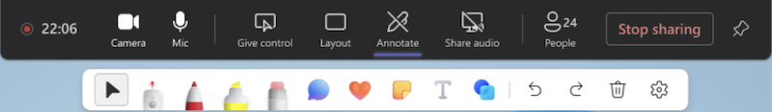
- Select one of the tools in the Whiteboard toolset — such as Sticky notes — and start typing or drawing on the screen.
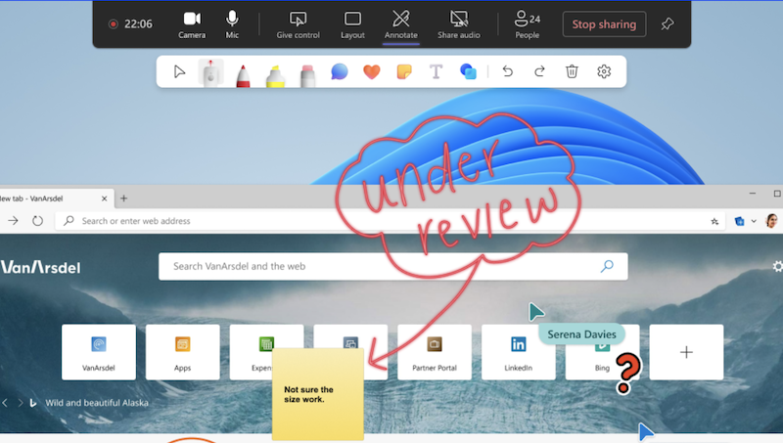

From EMIS Activity to Business Value
Installing an EMIS is an important investment, but installation is only the starting point. Sustained value depends on how effectively the organization uses the information the EMIS provides.
An EMIS may collect data and generate reports without consistently influencing operational decisions, project planning or management priorities. Too many alerts, overly technical reports, unclear ownership and limited follow-through can all create gaps between EMIS activity and business value.
Where does your organization experience the greatest challenge?
Consider whether any of the following apply:
- Too much information and not enough prioritization
- Reports are technically accurate but difficult to act on
- Messaging is not tailored to different audiences
- Management does not see a clear connection to business priorities
- EMIS findings do not influence existing operational or planning processes
- Improvement stops after the first project or success

Sustaining the EMIS Through continuous Improvement
A successful EMIS does more than display information. It helps the organization focus on what matters, communicate useful findings, support credible decisions and identify new opportunities.
The following five-step framework provides a practical means to connect EMIS information to continuous improvement:
- Prioritize what matters: Focus attention on the information and opportunities with the greatest potential value
- Communicate for the audience: Present information in a manner that helps each audience understand, decide or act
- Build credibility with a win: Demonstrate one clear and measurable success
- Integrate into business processes: Integrate EMIS findings into existing operational, planning and governance routines
- Improve and repeat: Use feedback and results to strengthen the EMIS and begin the next improvement cycle
The goal is not to create a perfect system. The goal is to create a system that continues to learn and improve.

Prioritize what matters
An EMIS can generate more alerts and opportunities than staff can investigate. Prioritization focuses attention on issues with the greatest operational, financial or energy value.
Questions to consider:
- Could this affect operations or production?
- Could it produce significant savings?
- Does it require immediate attention?
- Is there enough information to act?
- Is ownership clear?
- Is it aligned with an organizational priority?
Apply it:
What criteria should your organization use to prioritize EMIS findings?
What alert, trend or opportunity deserves greater attention?

Communicate for the audience
Different audiences need different information. Operators may need an action, while management may need data on business impacts, risks or returns on investment.
Questions to consider:
- Who needs the information?
- What do they care about?
- What decision or action is needed?
- What level of detail is appropriate?
- What is the clearest way to communicate it?

Translate one EMIS finding
Finding or opportunity:
Audience:
What do they care about?
What should they understand, decide or do?
How will you communicate it?

Build credibility with one meaningful success
A clear, measurable result can build more support than a large technical report.
For example:
Last month, we reduced compressed air losses by 8%, saving approximately $18,000.
Plan a success story
Problem or opportunity:
Action taken:
Measurable result:
Why it matters:
Next action or decision:

Integrate EMIS into Business processes
EMIS findings need a clear path into the routines where work is assigned, projects are planned and decisions are made.
Use existing:
- Operational meetings
- Maintenance planning
- Project development
- Budgeting and capital planning
- Management reviews
Apply it:
Finding or opportunity:
Where should it go next?
- Operational meeting
- Maintenance planning
- Project development
- Capital planning
- Management review
- Other: ______________________________
Who owns it?
What needs to happen next?

Improve and repeat
After each cycle, gather feedback and improve the EMIS, reports and decision-making process.
After each cycle:
- Ask users what was helpful or confusing
- Remove unnecessary alerts and information
- Improve dashboards and reports
- Document results and lessons learned
- Identify the next opportunity
Reflection
What change would make your EMIS more useful?
What feedback should you gather and from whom?
What opportunity could begin the next cycle?

Practice scenario: Food manufacturing facility
A food manufacturing facility uses an EMIS to monitor refrigeration, compressed air and boilers. The energy manager sends detailed weekly reports, but management says there is too much information. Only one improvement project has been approved.
Discuss:
- What should facility staff do first?
- Who needs different information?
- What quick success could build credibility?

Breakout Discussion: turn practice into learning
- Why is prioritization more valuable than simply collecting information?
- How would your organization decide what deserves management attention?
- What has changed in your thinking about EMIS reporting or decision-making?

My next step
Choose one realistic action to improve how your organization uses EMIS data.
Possible actions include:
- Review who receives EMIS reports
- Identify one opportunity using existing data
- Simplify a report
- Establish prioritization criteria
- Connect an opportunity to an existing process
- Review how the EMIS supports your EnMS or PDCA cycle
My commitment
Action:

Opportunity or issue:

People to involve:

First step:

How I will measure progress:

Additional support and resources
Save on Energy offers programs, funding, training and coaching to support energy management and EMIS improvement.
Resources include:
- Expanded Energy Management Program and EMIS incentives
- XLerate Program
- Retrofit Program
- Energy management coaching
- Energy management community
- Save on Energy training and resources
- The Energy Manager’s Playbook podcast
- Enabling incentives

