ESTIMATING PROCESS COOLING SAVINGS

Participant workbook

How do you know if an energy-saving opportunity is worth pursuing? After identifying an opportunity, you'll likely want to estimate the savings to evaluate if it's worth putting more effort and resources into it.

Understanding how to develop a reasonable estimate of energy savings can be very useful, but you need to know what tools or calculations to use, what assumptions are going into those estimates, and under what conditions they're valid.

## In this workshop, participants will:

* Apply the four-step framework to estimate savings on process cooling and

refrigeration projects.

* Identify areas where a different estimate approach is required depending

on applicability and available data.

* Gain expert insights to confidently address questions

and refine techniques for estimating savings.

This workshop will be hosted over

Teams.

# Energy savings in process cooling

Process cooling and refrigeration includes chillers (air and water cooled), pumps, fans, motors, distribution systems (pipes, values, etc.) These systems use 15-40% of total energy consumption. Consider your operations. **What process cooling systems do you currently have or are planning to implement?**

|  |
| --- |
|  |

# Applying a framework for a structured approach

To ensure energy saving calculations are accurate and appropriate, a structured approach is critical for success. The following framework provides the basic steps in this approach:

1. **Assess available data** – know that you have the right data to meet your required level of uncertainty.

* Gather equipment details and specifications.​
* Understand usage patterns​.
* Identify what is metered and how data is logged.

1. **Establish a baseline** – understand the total energy use to know that savings estimates are in the right ballpark.

* Estimate or measure the total energy consumption​.
* Understand energy consumption over different seasons, production schedules and types of operation​.
* Consider runtime, duty cycle and partial loads.

1. **Understand the savings mechanisms** – know how your system reacts to changes to avoid incorrect assumptions in estimates.

* Understand how changes to the system affect how equipment works and how those changes can lead to energy savings​.
* Avoid under-or over-estimation by ​ensuring the estimated savings reflect how the equipment is actually operated.

1. **Calculate savings** – choose the right calculations or rules of thumb.

* Apply rules of thumb, tools, or calculations to estimate project energy savings.
* Apply your understanding of savings mechanisms to ensure you aren’t using calculations that don’t include assumptions that don’t apply to your system.
* Compare savings estimates to baseline annual energy consumption to check for reasonableness.

# Step 1: Assess available data

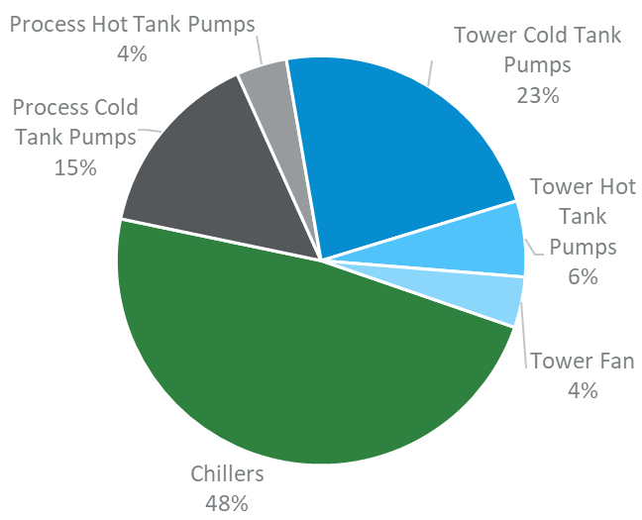The first step in the framework is to access all available data. Since energy-saving opportunities are often trade-offs between how much energy is used in different components, it’s important to take a systems approach when gathering available data that includes:

* Chiller
* Colling tower pumps and fans
* Process cold water pumps

Try to gather as much available data as possible to provide the level of accuracy required for your cost savings estimate.

Figure : Example of end-use energy consumption. Source: ACEEE. Energy Efficiency in Industrial Process Cooling. 2003.

Ideally, look for:

* Measured kW or amps for key components
* Logged temperature and flow of the chilled water circuit and cooling tower circuit
* Pressure
* Logged production data

At a minimum, try to gather:

* Equipment details and specifications including:
  + Constant or variable speed chiller and pumps
  + Compressor and pump ratings and efficiencies
  + Chiller load profiles
* Temperature set points (loads)
* Logged temperature and flow of chilled water circuit

What data do you typically have available for your process cooling equipment?

|  |
| --- |
|  |

## Use mitigation strategies to fill in data gaps

Real world data can be challenging to find and gaps in information are common. Mitigation strategies are available to generate an accurate approximation of data you need. These include:

* Regular data logging
* Using proxy data
* Modelling and estimating
* Data filling, extrapolation/interpolation, averaging, etc.

### Important!

Incorrect estimates of flow are one of the largest sources of error when estimating energy consumption. Whenever possible the flow of chilled water should be measured.

### Using engineering calculations

The equation:

$$Q=mC_{p}∆T$$

is critical for filling in data gaps. For this equation:

* Q is the heat energy (J/s or W)
* m is the mass flow (kg/s) in flow obtained by multiplying flow rate (m3/s) by density (kg/m3)
* Cp = specific heat capacity of the substance (J/kg-K)
* ∆T = is the temperature change (K)

Linear regression and interpolation (as shown in the equations below) can also be used to generate missing data.

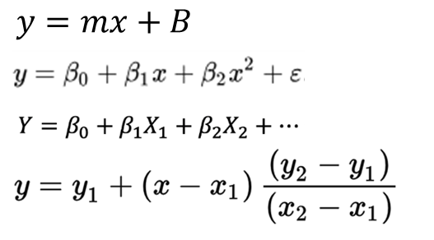

### Example mitigation strategy: Using the cooling capacity formula

The following explains how to estimate power using the cooling capacity formula (Q = ṁ x Cp x ΔT). For this equation: m is mass, flow = volume flow rate x density (at conditions), Q = useful cooling.

To use this equation, you’ll need:

* The inlet and outlet chilled water temperature (ΔT)
* The volume flow rate of water into the evaporator

You should be able to look-up water properties (density and specific heat (Cp)) at the given temperatures (take the average of the inlet & outlet temperatures). Remember to add 273.15K to Celsius to convert it to units of Kelvin.

If you have a reliable coefficient of performance (COP) from your equipment spec or elsewhere, you can use this formula to estimate electrical power input per COP = Q / W, where W is work in kWe.

Alternatively, if you can calculate the COP if you have power (kWe) or, if you have COP and W, you can use this formula to validate your operating parameters, i.e. volume flow rate of ΔT.

# Step 2: Establish a baseline

The second step in the framework is establishing an accurate baseline of energy consumption. In this step, you will estimate or measure the total energy consumption, capturing the variations over different seasons, production schedules and changes in operations.

For this step you will need to:

* Estimate or measure the total energy consumption
* Understand energy consumption over different seasons, production schedules and types of operation
* Consider run time, duty cycle and partial loads

There are three different approaches to establishing a baseline:

|  |  |
| --- | --- |
| Method of estimation | What it entails |
| Basic formula-based approach | Power (kW) x time (hours) |
| Engineering calculation approach | Using specifications, load profiles, temperatures and process load data to develop an excel based baseline model |
| Modelling approach | An MS Excel-based linear regression model OR a software-based model (e.g., vendor software) |

**What approach do you typically use in your daily analysis?**

|  |
| --- |
|  |

## Calculating a basic baseline

For small projects or if a low-effort estimate is all that is required, a basic formula approach can be used.

In this approach:

* Energy (kWh) = Power (kW) x Hours of Operation (h)
* Power (kW) = V x I x PF x √3
* Efficiency (COP) = Useful Cooling (kW) / Power Input (kW)

### Example basic baseline calculation

This example of a basic baseline calculation will calculate the cooling load (Q) under different operating conditions using:

* Chilled water flow rate varies between 0.05 to 0.1 m3/s
* Inlet temperature varies between 10 to 12 C
* Outlet temperature varies between 6 to 7 C

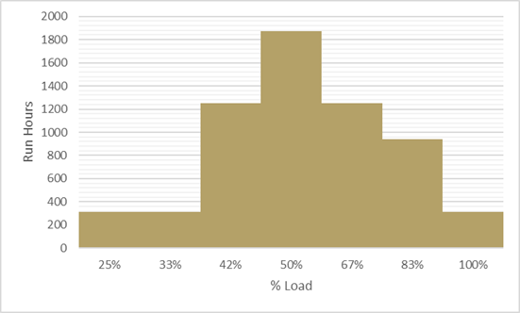

In this example:

* Q calculated from measurements of flow and ΔT
* COP is calculated from performance curve
* Input kW is derived from Q x COP
* MWh is determined by input kW x Hours

The rated cooling capacity = 2,500 kW or 711 tons which allows us to calculate the % load (or part load ratio) for a given Q and then use the chiller performance curve to identify the corresponding COP.

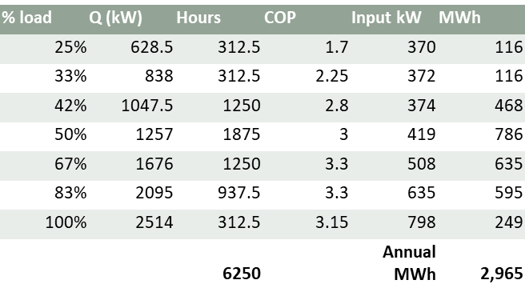

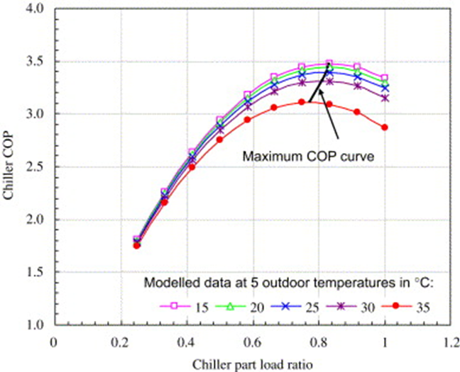

Image source: F.W. Yu, K.T. Chan. 2006.

## Developing a model for more accuracy

If higher accuracy is required, a model-based approach should be used. Often Excel-based, this approach uses a combination of bin analysis, regression formulas, hourly temperature or weather data. This approach provides a more accurate estimate and can be used for budgetary estimates, incentives and pre-design project evaluations.

To calculate energy baseline from the model:

1. Collect the annual dataset of hourly outdoor air temperature and production levels if appropriate.
2. Use a regression formula to calculate the hourly chiller plant load (TR).
3. Transpose hourly TR to a % load of chiller on the chiller performance curves.
4. Convert the hourly % load of chiller to input kW using curves and hourly TR data.

## Employing advanced modelling for more certainty

When you need data with a high degree of certainty, utilize an advanced modelling approach. This approach utilizes whole building simulation software to predict energy consumption of processes and buildings on an hourly basis. Models are calibrated with hourly data and are of high accuracy.

Common application of this approach is in the design process of advanced systems. The approach usually requires subject matter expertise and is often carried out by a third-party consultant.

### Important:

The results of this approach are usually proprietary in nature. It will provide high quality data/information that you may otherwise not have been able to model, but at a higher cost.

## Outcome of step 2: Establish a baseline

By establishing a baseline, you will:

* Develop an understanding of the total energy consumption of the system across all mode of operation is developed
* Uncover errors in savings estimates that become obvious when seen as an unreasonable percentage of total consumption

An accurate baseline provides guardrails to keep savings estimates on track.

# Step 3: Understanding the savings mechanism

The third step in the framework is understanding the savings mechanism. It is important to understand how changes to the system affect how equipment works and the savings potential. To do this, ensure the estimate is based on how the equipment is actually operated and verify that the estimated savings reflect reality.

## chiller savings mechanisms

Process cooling energy-saving opportunities result in savings because they impact one of the following savings mechanisms.

* Reduce the cooling load
* Reduce the chiller lift
* Improve the efficiency of cooling
* Reduce flow/pressure

### Reducing Chiller load

To reduce cooling load, consider:

* Pipe insulation
* Removing unnecessary piping / disconnecting old loads
* Reducing heat sources in cooled areas
* Remove scaling

The impact of these changes is that the chiller will run at a lower load percentage. Remember that part-load efficiency is important and will impact the overall energy reduction.

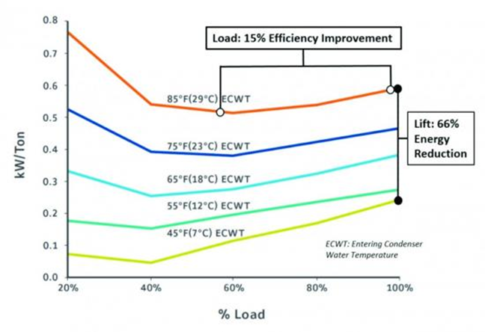

*Image source: Fred Berry. Chiller & Cooling Best Practices. VSD Chillers Deliver Energy Savings Under Real World Conditions. 2017.*

### Increasing the chilled water supply temperature

Another saving mechanism to consider is to increase the chilled water supply temperature. With this option, the chiller will not have to work as hard; however, in a variable flow system, this option will cause the pumps to work harder. The figure below illustrates this balance for a small system with no secondary pumps of variable speed fans. More complex system may need to consider the energy impact of other building-side components such as evaporator fans, etc.

Some examples of opportunities to increase the chiller water supple temperature include a CHW temperature reset or an adjustment of the setpoints.

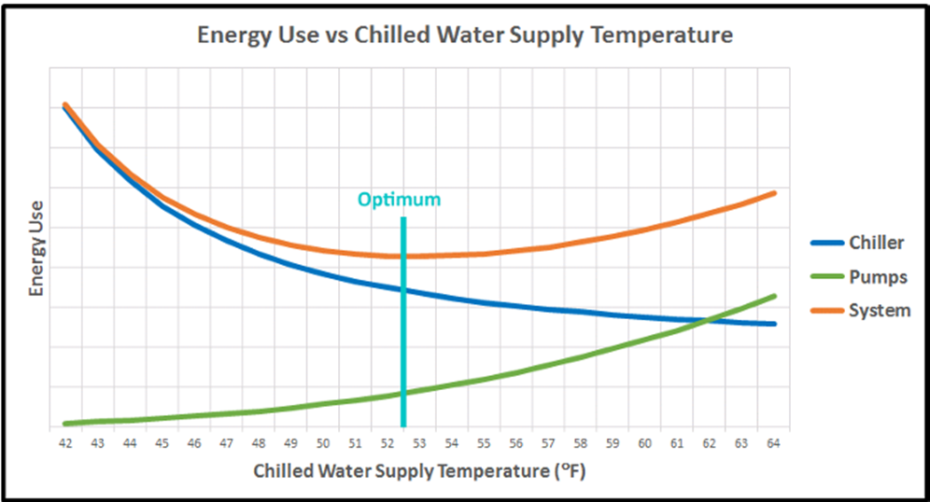

*Source: Carrier. Chilled Water System Optimizer. 2017.*

### Decreasing the condensing water temperature

Decreasing the condensing water temperature is another option to reduce the load on the chiller, with the caveat that the cooling tower will need to work harder. This option can be achieved through a condensing water temperature reset or by changing the setpoints.

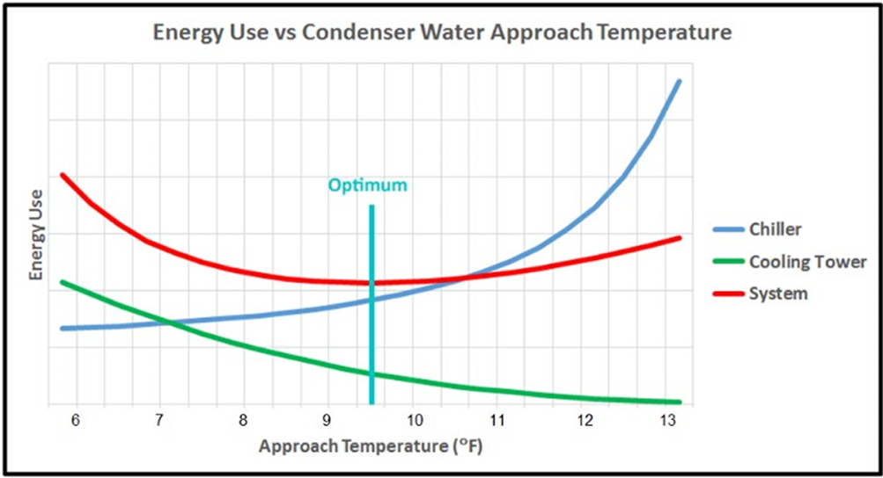

*Source: Carrier. Chilled Water System Optimizer. 2017.*

## Improve the efficiency of cooling

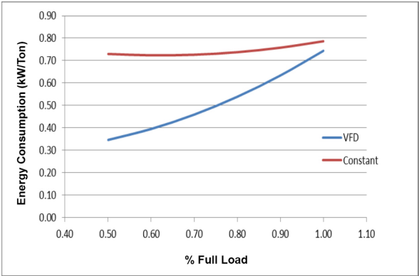This savings mechanism includes improving the efficiency of the chiller or other system components. It allows the process cooling system to meet the required cooling needs with less energy input. This can include:

* Higher efficiency chiller units.
* Upgrade to variable speed chiller to improve part-load efficiency.
* Improve sequencing of multiple chillers.
* Install a water-side economizer.
* Improve efficiency of other components.

In most cases, these improvements will change the chiller performance curve, either shifting it towards higher efficiency, or changing the slope to improve efficiency at lower load levels.

Image source: Yakasawa. How to Cut Chiller Energy Costs by 30%. 2015.

## Reduce flow/pressure

Reducing flow of chilled water can be accomplished by installing advanced controls with variable speed drives (VSDs) or by reducing flow of pumps in a constant flow system (want to maintain a ∆T of ~10 C).

Additional information on savings mechanisms for pumps systems is available in the [*Estimating Project Savings: Pumps and Fans* workshop](https://www.youtube.com/watch?v=d81KfRpO_OE&t=16s).

**What savings mechanisms do the efficiency opportunities you identified make use of?**

|  |
| --- |
|  |

# Step 4: Calculating the savings

The fourth step in the framework is to calculate the savings. At a high-level, this step can be summarized in the statement below:

Energy Savings = Adjusted Baseline – Reporting Period +/- Non-Routine Adjustments

## Common rules of thumb for calculating savings

* Each degree C reduction in **entering condensing water temperature** results in 1.2% increase in chiller efficiency.
* Each degree C increase in **chilled water supply temperature** results in 1-2% increase in chiller efficiency.
* **Older chillers** can consume 0.60kW per ton of cooling
* **Variable speed drives** on chillers can result in up to 30% energy savings

## Chiller plant efficiency in HVAC applications

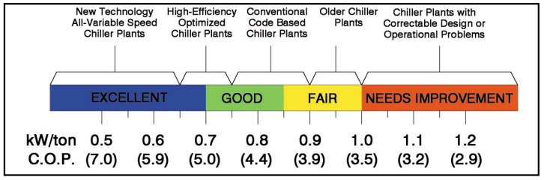

## Saving calculation: Optimizing evaporator delta T

* Rule of thumb: for every increase of 1C in delta T, pumping requirements reduced by 8%.

**What energy savings calculations are available for your process cooling systems?**

|  |
| --- |
|  |

# Conclusion

The final output of the framework is a defensible and repeatable analysis that can be used to prove project savings to evaluators and internal stakeholders.

By employing the systematic approach provided by the four-step framework, you can be confident that your savings estimates are grounded in reality.

Additionally, you can avoid inaccurate estimates that put your reputation at risk and question the value of energy efficiency initiatives.

Finally, a reminder that ongoing data logging, measurement and verification activities will ensure that the energy savings persist in the future.

## Additional Resources

* [ACEEE: Energy Efficiency in Industrial Process Cooling Systems (2003)](https://www.aceee.org/files/proceedings/2003/data/papers/SS03_Panel4_Paper_26.pdf)
* [USDOE: Process Cooling System Info Card](https://betterbuildingssolutioncenter.energy.gov/sites/default/files/attachments/BP_Process%20Cooling%20Systems_Info%20Card_Final.pdf)
* [USDOE: Online Learning Webinar – Process Cooling Systems](https://betterbuildingssolutioncenter.energy.gov/sites/default/files/slides/Week%2012%20-%20Process%20Cooling.pdf)
* [Lecture on conducting bin calculations](https://www.youtube.com/watch?app=desktop&v=VWp-tjUyqNk) (2021)
* [USDOE: MEASUR Tool Suite](https://www.energy.gov/eere/iedo/measur) (includes psychrometric calculator, weather binning calculator, cooling tower make-up water calculator)
* [Wulfinghoff: Keep Chilled Water Supply Temperature as High as Possible](https://energybooks.com/wp-content/uploads/2015/07/264266.pdf) (1999)
* [Energy Models: Heating and Cooling System Upgrades.](https://energy-models.com/heating-and-cooling-system-upgrades)
* [Part load performance of air-cooled centrifugal chillers with variable speed condenser fan control](https://www.sciencedirect.com/science/article/abs/pii/S036013230600432X) (2007)

## Questions and Answers

|  |
| --- |
| **Notes:** _____________________________________________________________________  _____________________________________________________________________  _____________________________________________________________________  _____________________________________________________________________  _____________________________________________________________________  _____________________________________________________________________  _____________________________________________________________________  _____________________________________________________________________  _____________________________________________________________________ |