Estimating Pump & Fan Project Savings
Participant Handout
How do you know if an energy-saving opportunity is worth pursuing? After identifying an opportunity, you'll likely want to estimate the savings to evaluate if it's worth putting more effort and resources into.
Understanding how to develop a reasonable estimate of energy savings with limited information can be very useful, but it's important to understand what tools or calculations to use, what assumptions are going into those estimates, and under what conditions they're valid.
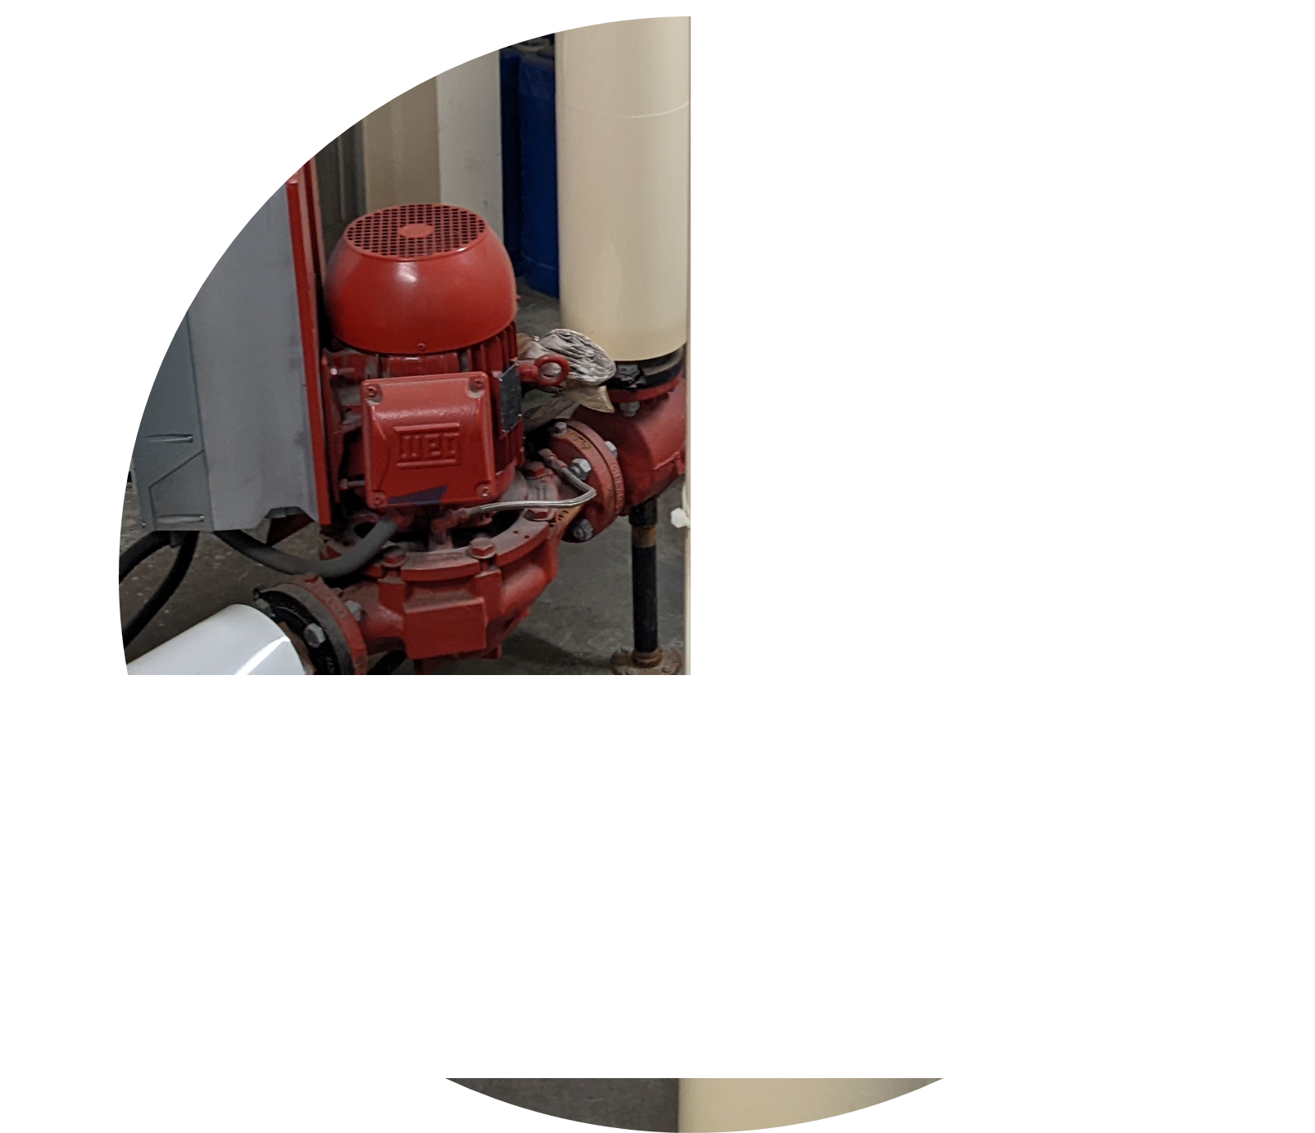

In this workshop, participants will:
- Learn how to estimate energy savings from pumps and fans projects, including what tools or calculators can be used.
- Understand when to apply different estimation approaches depending on applicability and available data.
- Have questions about estimating savings answered by Vern Martin.

This workshop will be
hosted over Teams.

Pump & Fan System Fundamentals
While it isn’t the objective of this workshop to cover the fundamentals of pump and fans systems in depth, there are a couple key concepts to keep in mind when estimating project savings:
- Understanding how to use pump and fan curves.
- Understanding system curves and the relationship between pump/fans and the system curve.
- Understanding the pump and fan power equations.

Pump and Fan Curves
Pump/fan curves depict the relationship between flow and pressure (or head), for a given pump/fan. Pumps/fans should operate at or close to their “best efficiency point” (BEP), which should be shown on the curve.  Additionally, pump/fan curves typically provide a brake-horsepower (BHP, i.e. mechanical power) curve for the possible flow range.  Pump/fan curves may include multiple curves for a range of impeller (pump) or sheave (fan) diameters.  IF a pump/fan is operating per design, knowing one of the three flow, pressure, or power variables allows you to interpolate the other two. | 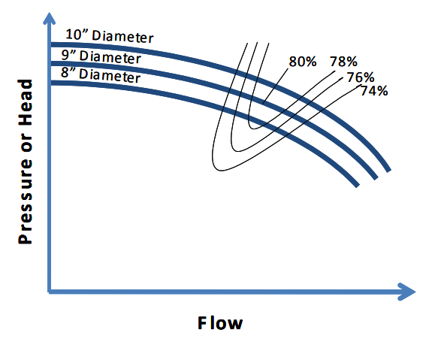  In practice, systems change over time, and the more you know (e.g. has the impeller been trimmed?), the more you can learn from the curves.

System Curves
A pump or fan will always operate at the intersection of the pump/fan curve and the system curve.
The system curve is the relationship between pressure and flow, including the static pressure (lift) and friction generated by the pipes/ducts, etc. as flow increases.
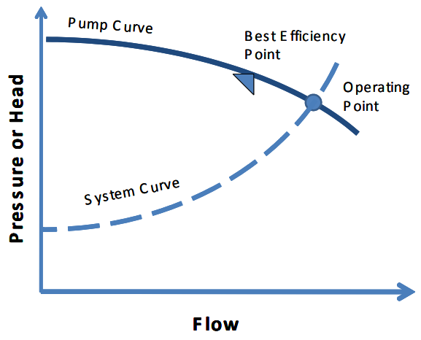 | 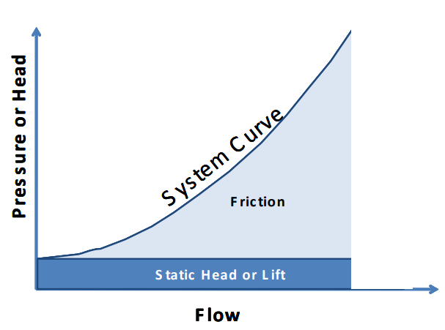
The following Energy Efficiency Reference Guides published by a consortium of Canadian utilities and agencies provide good overview of pump and fan system fundamentals and energy efficiency considerations:
- Pump Systems Energy Efficiency Reference Guide
- Fans & Blowers Energy Efficiency Reference Guide

Pump & Fan-side, Mechanical Power Calculations
To check what your pump/fan curves are telling you, or if curves are not available or reliable (e.g. old equipment), use the pump/fan equations to calculate mechanical power (P_{m}).
Pump equation  $$\text{P}\text{m}\text{ = }\frac{\text{ρ × g × Q × H}}{\text{η}}$$  Where:  P_{m} = Mechanical power requirement for pump [W]  ρ = Density of fluid handled [kg/m³]  g = Gravitational constant [m/s²]  Q = Flow rate of the pump [m³/s]  H = Head of the pump [m]  η = Pump efficiency [%]  Typical pump efficiency at its best efficiency point = 75-85% | Fan equation  $$\text{P}\text{m} \text{=} \frac{\text{V}\text{ × ∆}\text{p}\text{ ×} {\text{10}}^{\text{-3}}}{\text{η}}$$  Where:  P_{m} = Mechanical power requirement for fan [kW]  V = Quantity of gas delivered [m³/s]  Δp = Total increase of pressure in fan [Pa]  η = Fan efficiency [%]  Typical fan efficiency at its best efficiency point = 60-70%

Divide by motor efficiency (and VFD, if applicable) to get Electric Power
P_{e} = P_{m} / (η_{motor} x η_{VFD})

Where:
P_{e} = Electrical power [W]
P_{m} = Mechanical power
η_{motor} = Motor efficiency [%]
η_{VFD} = VFD efficiency [%]

Potential alternative if the pump/fan motor has a VFD:
- Motor load can be estimated based on drive frequency (Hz), using the affinity/fan laws:
$$\frac{{\text{BHP}}_{\text{1}} }{{\text{BHP}}_{\text{2}}}={\left[\frac{{\text{n}}_{\text{1}}}{{\text{n}}_{\text{2}}}\right]}^{\text{3}}$$
- Caution:
  - Don’t forget to consider the motor and VFD efficiency, particularly at lower loads.
    - For typical VFD efficiency v. motor load by motor sizing, see Table 1 (page 2) of the DOE’s Adjustable Speed Drive Part-Load Efficiency.
  - The equations assume no static pressure (head) and should therefore be downgraded for systems with some static pressure (e.g. [n₁/n₂]²), or not used.
See Variable Speed Pumping, A Guide for Successful Applications, Executive Summary, for more information on VFD application in pumping systems.

Notes & References
- Motor Efficiency – for premium motor efficiency v. motor load by motor sizing, see Table 4.6 or Figure 4.4 or (page 63) of the DOE’s Premium Efficiency Motor Selection And Application Guide
- Use pump/fan curves and estimated operating point to estimate actual efficiency v. design.
- Has the pump impeller been trimmed or your fan re-sheaved? If your data and calculations aren’t making sense, this might explain why.

Calculating Electrical Power & Energy Baselines

Motor-side, Electrical Power Calculations
The most reliable way to calculate electrical power (P_{e}) is to measure power, but if you have less-than-perfect information, there are a few options, with varying degrees of accuracy.

Nameplate Method
If you’ve got nothing but the motor nameplate and just need a rough estimate, you can start here:
$${\text{P}}_{\text{e}}\text{ =}\frac{{\text{ hp}}_{\text{nameplate}}\text{ × 0.74}\text{6}\text{ [kW/hp]} \text{×}\text{ Load Factor }}{\text{η}\text{motor}}$$
Where Load Factor (LF) can be your best estimate between 0% - 100%
- Keep in mind that most equipment is overdesigned (i.e., includes a “capacity factor”).
- The better you know the equipment in your facility (e.g., metering of similar systems), the better your estimates will be.
- See below for more notes on load factor and duty cycle.

Calculating Power from Current (Amps)
Moving up in order of accuracy, Amp measurements can be a good substitute for power.
To calculate three-phase power from Amps, use the following equation:
$$\text{P}\text{e}\text{ =}\frac{\text{V × I × PF × }\sqrt{\text{3}}}{\text{1000}}$$
Where:
P_{e} = Three-phase power [kW]
V = RMS voltage, mean line-to-line of 3 phases [V]
I = RMS current, mean of 3 phases [A]
PF = Power factor as a decimal [-]
Or use the percent of full load Amps (FLA) method:
The amperage draw of a motor varies approximately linearly with respect to load (power), down to about 50% of full load. Below the 50%-point, power factor degrades, the amperage/power curve becomes increasingly non-linear, and Amp measurements are not a reliable indicator of load. Use the three-phase power equation in these cases and see the power factor notes and references below.

Notes & References
- Power Factor: for typical power factor v. motor load by motor sizing, see Figure 4.5 (page 63) of the US Department of Energy’s (DOE) Premium Efficiency Motor Selection And Application Guide

Potential alternative, if power and Amps aren’t available:
- The Slip Method: When only operating speed measurements (i.e. RPMs) are available: https://www.energy.gov/eere/amo/articles/determining-electric-motor-load-and-efficiency

Developing the Energy Baseline
After making the effort to come up with an accurate power estimate with the information available, don’t blow it when transforming your power estimate into an energy baseline. To accurately add the element of time you must consider load factor and duty cycle.
While power, flow, and pressure measurement may be hard to come by, production and operating systems typically have some form of operating data trend that can provide a proxy for the pump/fan systems operating mode. Make the effort to obtain a continuous trend of operating data to inform your load factor and duty cycle – when in doubt, 12 months is usually good.
The wrong assumption regarding load factor or duty cycle can be the difference between a good project and a bad one.

Load Factor
Does your pump/fan run at a constant operating point, does it have operating modes, or it variate continuously?
Load Factor refers to the load on a motor as a percentage of full load. The power calculations above explain how to calculate power, but depending on how a system operates / the load factor varies, you may need to perform multiple calculations.
The objective of this workshop is to develop “good enough” estimates to assess whether to invest more time and resources. The following suggestions are with this objective in mind:
Condition | Suggested Method
Operating data suggests a constant operating mode. If relevant operating data is unavailable, a knowledgeable and relevant resource is confident that the pump/fan operates at a constant load. | A spot measurement (e.g.: Amps) should be adequate.
Operating data suggests the pump/fan has multiple distinctly different operating modes. | A spot measurement (e.g.: Amps) of each mode should be adequate.
The pump/fan modulates significantly to meet system demands. (e.g.: high v. low heating/cooling/flow requirements, or different pressure based on varying tank heights). | A continuous trend measurement should be collected. It may be prudent to “bin” the measured data (Amps) into discrete ranges (e.g.: a histogram) to develop power calculations and the energy baseline.

Duty Cycle
Finally, the same or similar operating data will hopefully tell you the amount of time the pump/fan is running, at each operating point, and for how long it is turned off. Many projects overestimate savings simply by assuming the system runs more than it does.
If relevant data is not available, consider manually timing the system modes for as long as necessary to be sure you have captured a representative sample of cycles.
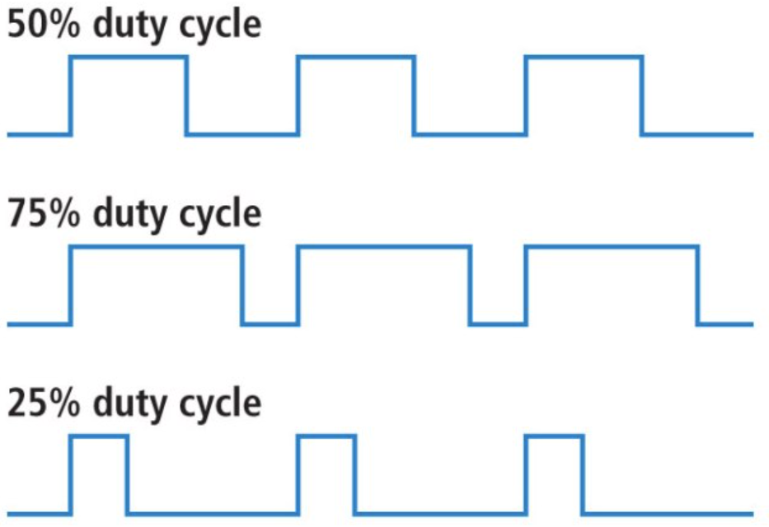

Combining Approaches to Validate Calculations
When working with imperfect data, combine approaches to improve baseline estimates and your overall understanding of the pump or fan system.
EXAMPLE 1: If you have a power calculation from Amps, pump/fan curves, and a pressure measurement at the pump/fan discharge pump/fan curves:
- Convert electrical power to mechanical power (BHP), based on a reasonable motor efficiency for the motor load (see reference above).
- Plot the pump/fan BHP on pump/fan curve and check alignment with pressure measurement. (or vice versa if you have a flow measurement, not pressure)
- If it lines up, you can have more confidence in your power calculation and pressure measurement, as well as the corresponding pump/fan flow and efficiency values from the curves.
- If it doesn’t line up, investigate potential reasons, such as:
  - The pump impeller has been trimmed / fan re-sheaved,
  - Your power calculation is inaccurate due to low-loading challenges,
  - The pressure gauge / flow reading is bad, or meter calibration is off,
  - The pump/fan has degraded, or the system has changed, such that the design spec and curves are inaccurate.
EXAMPLE 2: If you have a power calculation from Amps, and a pressure measurement at the pump/fan discharge, but no pump/fan curves:
  - Back-calculate the pump/fan flow using the pump/fan equation and a reasonable pump/fan efficiency assumption. (or vice versa if you have a flow measurement)
  - Does the flow value make sense? How can you check?
    - Look at pump/fan nameplate for model and specifications (search online to see if more information is available)
    - Reassess pump/fan efficiency assumption based on flow & pressure (e.g.: is the operating point likely to be near best efficiency, or not?) and recalculate.

Estimating SAvings
Estimating savings starts with your energy baseline, as described by these two approaches:
- Estimate the post-project power and energy consumption along the same methods described above. E.g.: if you are reducing flow, use the pump/fan equation to develop new power estimates and combine that with what you’ve determined for the load factor and duty cycle to estimate the post project energy consumption.
  - Take the difference of the baseline and the post project energy consumption to get the estimated energy savings.
- In some cases, it may be appropriate to simply estimate savings from the energy baseline. E.g.: A project may save 20%.
  - Multiply the baseline by the savings percentage to get the estimated energy savings.
  - BUT make sure to qualify the savings rate. E.g.: For a system with multiple operating modes, will the project save 20% for all modes?
When it comes to the tricky part of “how much will this save”, here are some suggestions:
- Trial the project, if possible.
- Rely on facts, where possible. (e.g., We shut the pump off at night, which is 12 hours)
- Use baseline data, combined with engineering calculations, such as described above for estimating post project energy consumption.
- Seek out expert opinions.
- Get vendor estimates.

Reducing Flow
Savings Mechanisms:  Move less volume, including turning pumps/fans down or off when not needed.  Solutions: Eliminate bypass or excess flow by right-sizing or by VFD; On/off controls; Fix leaks.  Calculation Pitfalls: Ignoring static pressure / head; Applying design conditions.  Notes: ________________________________  ______________________________________  ______________________________________ | 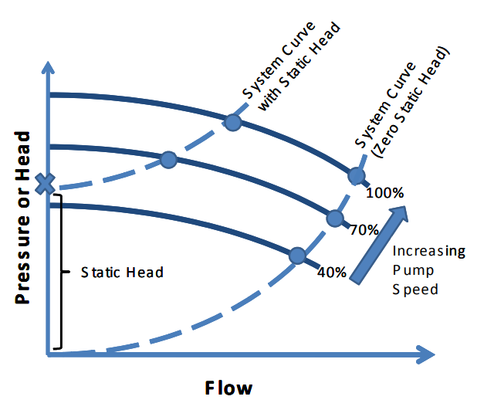

Reducing Pressure
Savings Mechanisms:  Reduce restrictions, reduce head/height differentials in open systems.  Solutions: Control with VFD to eliminate dampers / throttling valves; Increase pipe/duct diameter; Improve maintenance.  Calculation Pitfalls: Ignoring static pressure / head; Applying design conditions.  Notes: ________________________________  ______________________________________  ______________________________________  ______________________________________ | 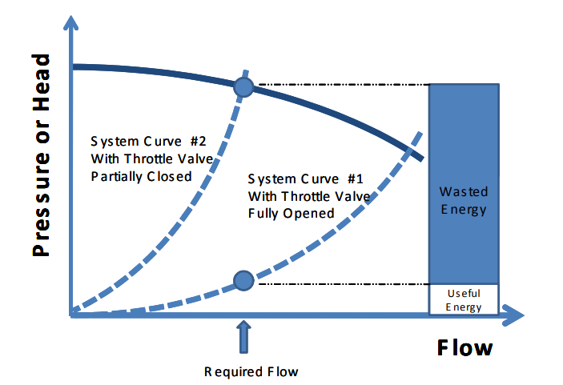

Increasing Efficiency
Savings Mechanisms:  Mechanisms: Operate at the Best Efficiency Point (BEP) or install higher efficiency equipment.  Solutions: Recommissioning; Right-sizing.  Calculation Pitfalls: Ignoring static pressure / head; Applying design conditions.  Notes: ________________________________  ______________________________________  ______________________________________  ______________________________________ | 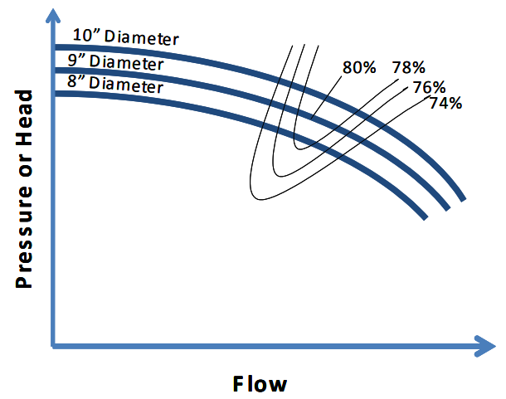

Questions and Answers

Notes:
_____________________________________________________________________
_____________________________________________________________________
_____________________________________________________________________
_____________________________________________________________________
_____________________________________________________________________
_____________________________________________________________________
_____________________________________________________________________
_____________________________________________________________________
_____________________________________________________________________

